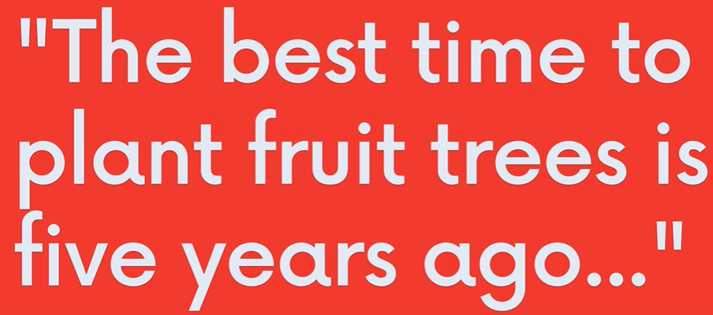  
  
  
  
  
YOUTUBE CHANNEL : **Colt Steele**

<https://www.youtube.com/channel/UCrqAGUPPMOdo0jfQ6grikZw>

<https://www.coltsteele.com/discord>

Course Curriculum:

GIT CORE:

Intro to Git

Installation

Git Basics

Committing In Detail

Branching

Merging

NEXT LEVEL GIT:

Diffing

Stashing

Undoing Changes

GITHUB/COLLAB CORE:

GitHub Intro

Fetching and Pulling

GitHub Odds & Ends

Collaborative Workflows

GIT: THE OTHER PARTS:

Rebasing

Interactive Rebasing

Git Tags

Git Behind the Scenes  
Re-flogs

Custom Aliases

???